**You can write CSS at 3 places**

1. Myth: The ability to write CSS, will make my website beautiful.

Fact: CSS comes at 3rd place among the factors that determine website’s beautifulness.

1. Font: Look, feel and theme of the website can be controlled with the help of font. Font consumes most of the space of the website.
2. Images: more beautiful images, their placing is key.
3. CSS: how good your button, card etc. look like?

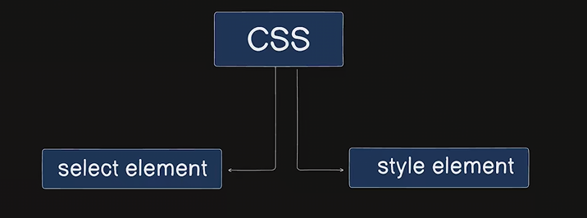

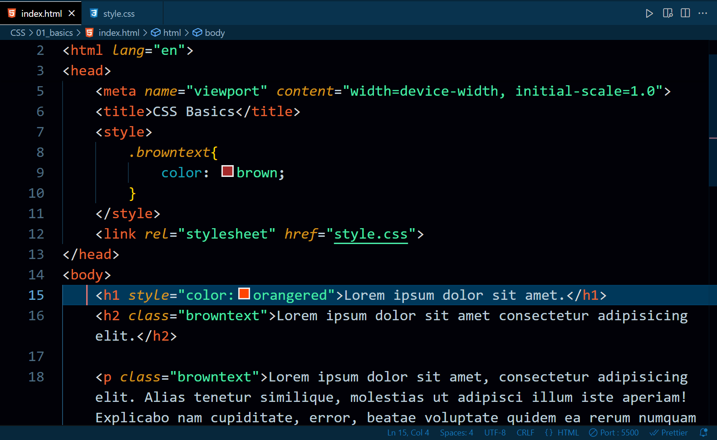

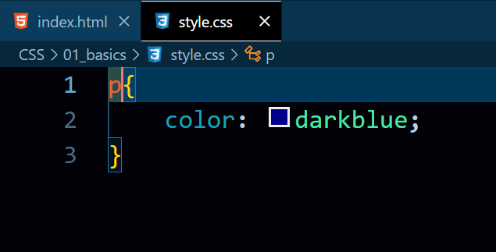

1. There are 3 types of CSS. They are:  
   a. **Inline CSS**: This CSS is written inside of an element.

b. **Internal CSS**: This CSS is written in the same file( for ex: index.html) in style tags i.e. <style></style> .

c. **External CSS**: This CSS is written inside an another separate file of CSS format. This external CSS file is connected to the index.html file using link tag.